Open GITHUB sign IN> create account with google account>

Create folder > right click on empty space> show more option> open git bash here >

Install GitHub desktop> open GitHub desktop>see you git bash files here>Below comment bar you can comment>Commit - files to main>Push origin
Open in browser git hub>Git Hub icon (user navigation menu>Repositories>Click your recent folder>sync for seeing latest modified files>
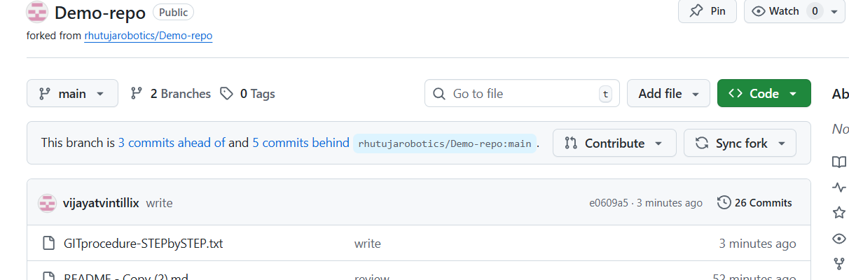

Go to main repository(ex as above picture ruthuja)>pull request>new pull request>compareaccrossforks>chose your name in second path>

Example of getting files from shared URL

Open git hub desk top>URL>past URL which you received>clone

